SIMATS ENGINEERING (SAVEETHA SCHOOL OF ENGINEERING)
Course Code & Title: | ECA5604 -5G/6G COMMUNICATION | Course Faculty: | Dr.K.Sathish
Student Name: | Velamuri Bhanodhay | Reg. No.: | 192412330
Dept / Batch: | BE.ECE / 2024 | Date: | 17/7/2026
Lab Observation

Experiment 3 :Spectrum Analysis of Sub-1 GHz, Mid-band & mm Wave by Plotting Propagation

Objective 1: To compute the Propagation Loss (dB) for Sub-1 GHz, Mid-band, and mmWave
frequency ranges using standard path loss models.

Matlab Code:

clc;clear
d=.1:.1:5; f=[900 3500 28000];
P=32.44+20*log10(f')+20*log10(d);

subplot(211)
plot(d,P)
grid on
title('Propagation Loss vs Distance')
xlabel('Distance (km)'),ylabel('Loss (dB)')

subplot(212)
plot(f,P(:,10),'-o')
grid on
title('Propagation Loss vs Frequency')
xlabel('Frequency (MHz)'),ylabel('Loss (dB)')

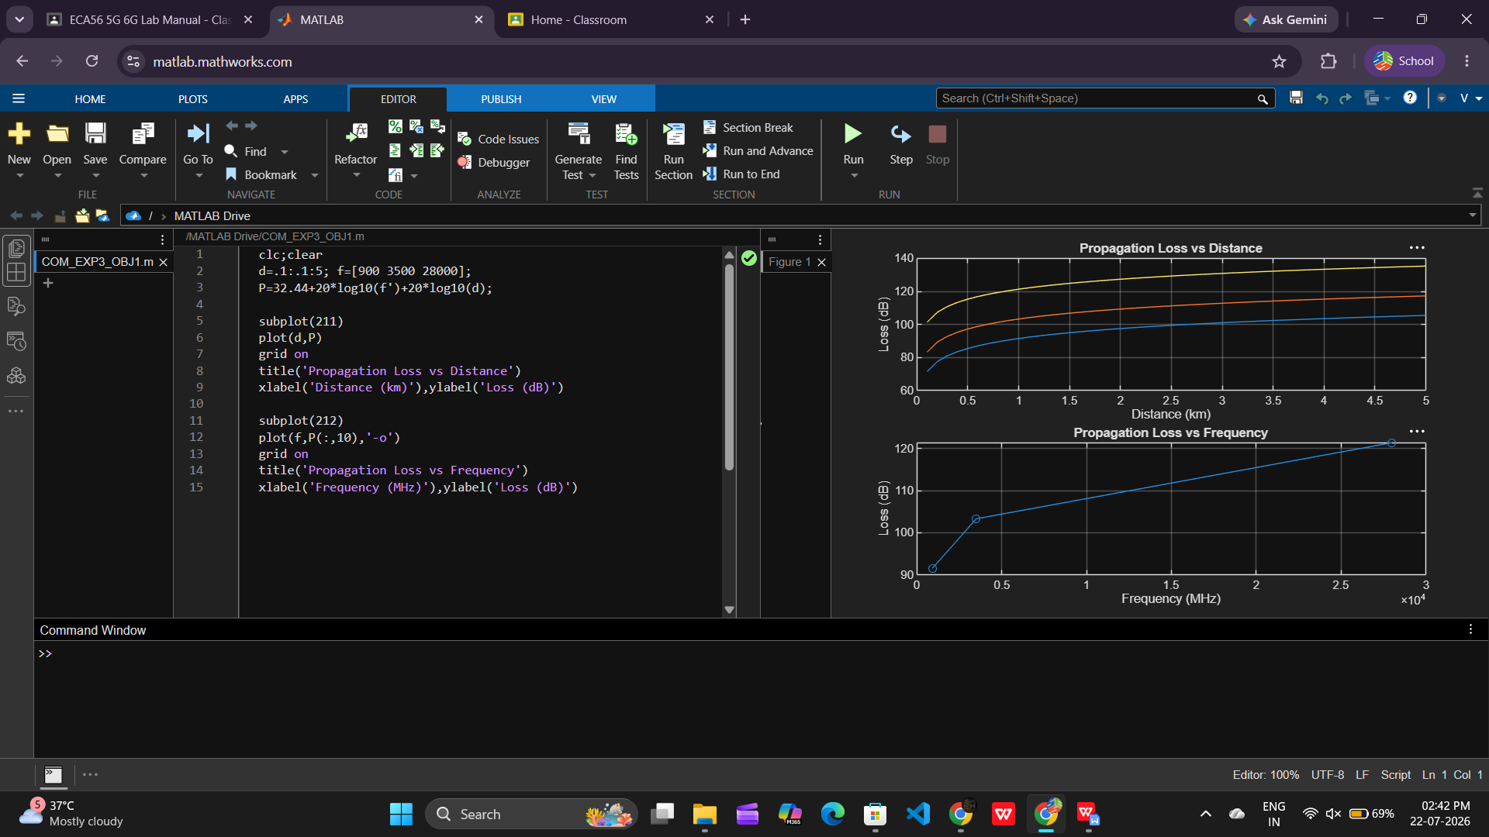

Objective 2: To evaluate the impact of different Operating Frequencies (GHz) on signal attenuation
and coverage performance.

Matlab Code:

clc;clear
f=[900 3500 28000];
P=32.44+20*log10(f)+20*log10(2);

subplot(211)
plot(f,P,'-o')
grid on
title('Propagation Loss vs Operating Frequency')
xlabel('Frequency (MHz)'),ylabel('Propagation Loss (dB)')

subplot(212)
bar(P)
set(gca,'XTickLabel',{'Sub-1GHz','Mid-band','mmWave'})
grid on
title('Comparison of Propagation Loss Across Bands')
xlabel('Frequency Bands (Index: 1=Sub-1GHz, 2=Mid-band, 3=mmWave)')
ylabel('Propagation Loss (dB)')

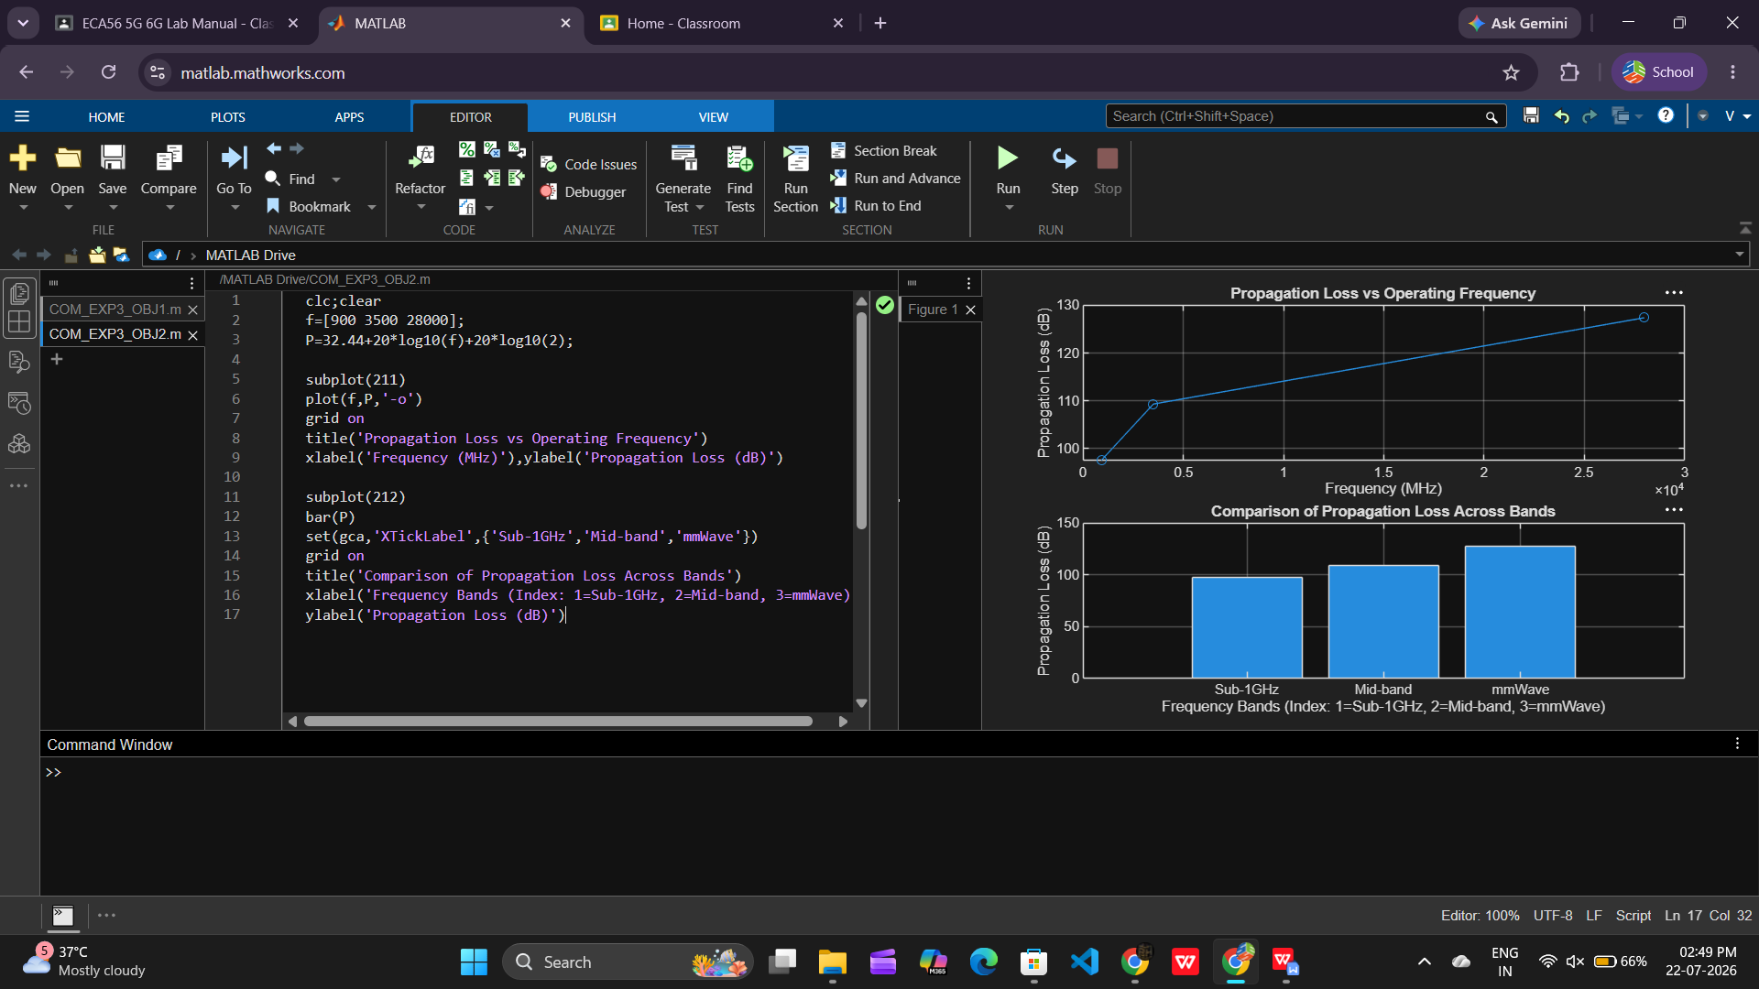

Objective 3: To analyze how Communication Distance (km) affects propagation loss across
different spectrum bands.

Matlab Code:

clc;clear
f=[900 3500 28000];
P=32.44+20*log10(f)+20*log10(2);

subplot(211)
plot(f,P,'-o')
grid on
title('Propagation Loss vs Operating Frequency')
xlabel('Frequency (MHz)'),ylabel('Propagation Loss (dB)')

subplot(212)
plot(1:3,P,'-s')
grid on
title('Band-wise Propagation Loss Comparison')
xlabel('Band Index (1=Sub1GHz, 2=Mid-band, 3=mmWave)')
ylabel('Propagation Loss (dB)')

